## Time Sheet

* Set appropriate column widths, wrap text for titles, bold the titles
* Set borders top and bottom, right justify numeric column headings
* Calculate gross pay = (Weekday hours + Weekend hours * Weekend rate) * Hourly Rate
* Format columns B – K as numeric with one decimal place
* Format columns L – M as numeric with two decimal places
* Bold the Total Payroll line and format amount as Currency with two decimals and thousand separator

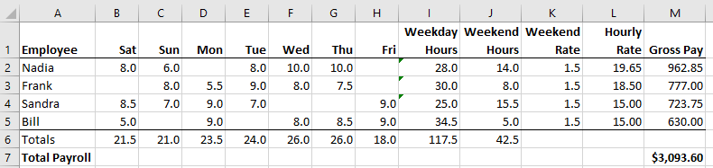

## Inventory

* Delete rows above Qty, Part Number etc.
* Autosize column widths
* Left align Part Number
* Delete USD column, format CAD column as two decimal places with thousands separator
* Create column TOTAL = QTY * CAD, format appropriately
* Apply Filter, select only Brand Linksys
* Sort on TOTAL

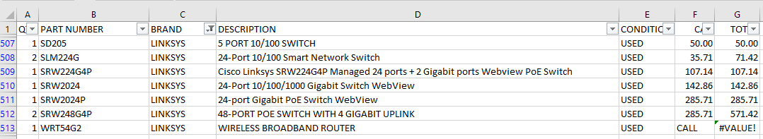

* Clear the Filter on Brand
* Sort on TOTAL
* What product has the greatest total value?
* Filter on CONDITION: USED

## Home Budget

* Resize columns
* Calculate Annual = Periods * Amount
* Format Amount and Annual columns as Numbers with 0 decimal places and thousands separator
* Put in a total

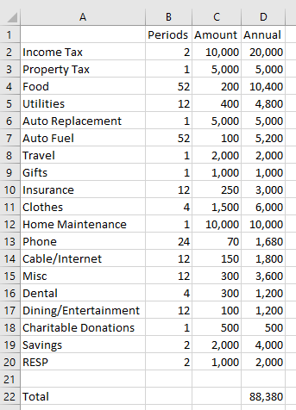

* Sort by Annual, what is biggest annual amount?
* Change Auto Fuel to $120 a week, what is new total?

## Box Office

* Split the screen to have a column heading line at the top
* Select columns Top 10 Gross and Gross, format as numbers with 0 decimal places and thousands separator
* Format Date as MM/DD/YY
* Sort by Movies Tracked, what is the maximum and minimum?
* Sort by Date
* Create column Top % = Gross / Top 10 Gross, format as percentage with two decimal places
* Which movie was biggest percentage of daily box? Smallest?

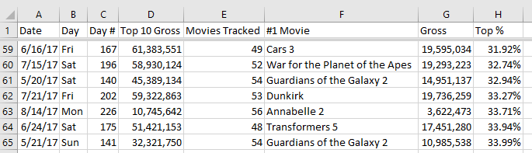

## Music

* Autosize columns
* Find The Tragically Hip, Find Next until it wraps around
* Remove double quotes
* What happened to song 1979, how to fix?

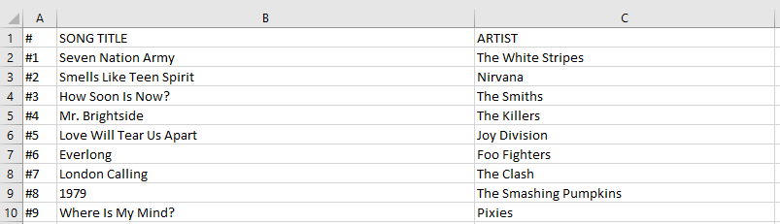

## Weather

* Resize columns, what happened to column B, manually adjust
* Select just the data (exclude legend)
* Sort data to find hottest day
* Sort data to find coldest day
* What day had the most snow fall
* What day had the most rain

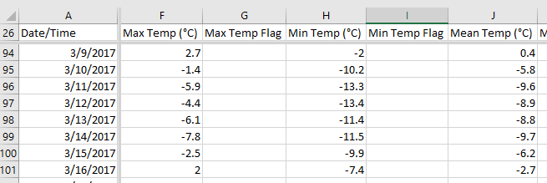

## Census

* Resize columns
* Wrap text for row 1
* Hide columns A, E
* Split Screen so heading and column B can be kept visible
* Hide columns J – M, O – R, so Totals for 2016 and 2011 are visible
* Insert a column to the right of 2011 Total called Growth = Total 2016 / Total 2011  
  Format as percentage with two decimal places
* How much has Halton grown?

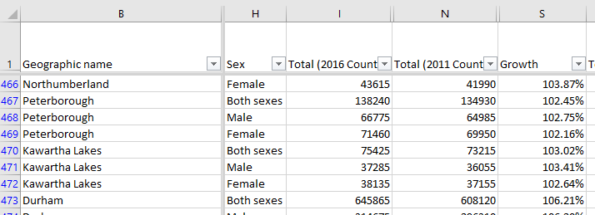

* Filter Sex to Both only
* Sort on Growth
* Which region has grown the most, contracted the most?